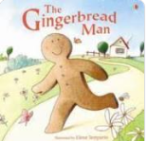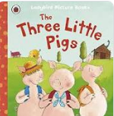

**Fridge words**- **materials strong stronger weak weaker gobbled first second third mood traditional tale anxious excited worried terrified petrified glad recycle describe adjective conjunction comparing ordering quantities estimate number bonds 3D shapes patterns Easter Jesus sacrificed new beginnings**

Our topics this term are Traditional Tales, building 9 and 10 and Easter. Please see the fridge words, have a fridge word box at home and add the fridge words in. Talk about the definitions of these words

Spring 2 Home Learning



**Spring Walk-** Visit a local park or local woodland and go on a Spring Walk. What do you notice about the trees? What can you see and hear? Are there any changes from winter to spring? Take some photographs. What else happens during Spring- Talk to your adult and research on an electronic device.

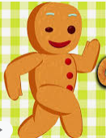

Draw a story map or write your own story about the Gingerbread Man. Change the main character to something else. You might even want to change the characters who chase him.

**Easter-** What is Easter and why do Christians celebrate Easter? Research. **Easter craft**- make an Easter card for a loved one or make an Easter bonnet. Take photos.

**Experiment-** Use three different materials you can find in your house to build a house for the three little pigs. Which one do you think will be the strongest? Which one do you think will be the weakest? Build your house or model and test it out by blowing it down. Did you predict correctly? What happened when you blew? Take photographs.

**3D shape hunt**- Look round your house for any 3D shapes. What shape is it? How many faces does it have? Take some photographs.

Please continue to read every night and learn the new phonics sounds and tricky words which we share with you on dojo.

**Number bonds to 10**- using objects or drawings, can you find all the different ways we can make ten by adding two number together? Write these down as number sentences.

Continue **counting forwards and backwards to 20** (or beyond if you’re ready) from any given number, not just from 1 e.g. 13-20 and back. 4-20 and back etc.

Continue **ordering and recognising** numbers to 20 and playing **one more than** and **one less than**.

Write down as many adjectives (describing words) that you can think of which describe the Big Bad Wolf from the Three Little Pigs Story. And then write some sentences using your adjectives and the ‘and’ conjunction e.g. The big bad wolf is mean and hungry.