**Notes 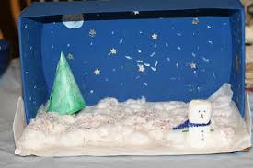 Creative Make a snowy scene to put your penguin in.**

**Nursery Rhyme of the Week**

Row Row Row your boat

Words of the day ( Fridge Words)

Week 3 18.1.21 Planning Overview

**Phonics**

Phase 3 Practise writing, recognising, I spy. Sounds w and x

Phase 2 ck, e,u,r

Blending words reading vc and cvc words

Tricky words phase 2 and he, she

**English**

Lost and Found

Learn the story and draw the story map.

Change the way they got to the South Pole.

Maths

Counting to 15 and beyond and back

Numbers

Compare Mass

Weighing objects which is the heaviest/ lightest. Can you order 3 objects from the heaviest to the lightest?

Cosmic Yoga

Andy’s Wild Workouts Cbeebies

**Topic**

Make bird cake

**Outdoor Classroom**

Robins Take binoculars and complete bird spotting sheet