Home learning grid – EYFS

 | Wednesday 16.9.20 | Thursday  17.9.20 | Friday  18.9.20 | Monday 21.9.20 | Tuesday  22.9.20 | Wednesday 23.9.20
English | Activity 1 - Daily reading Read a story together. You can use a book from home or look on https://www.oxfordowl.co.uk/for-home/find-a-book/library-page/  Activity 2 –  This week we have been learning the nursery rhyme Incy Wincy Spider . 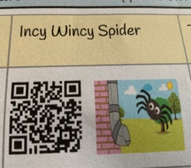  You can download a QR code reader free on iTunes app store and Google Play  Please sing the nursey rhyme with your child and put them performance on dojo.  Play the rhyming game and match the words that rhyme.  ( See attached Sheet) | Activity 1 - Daily reading  https://www.oxfordowl.co.uk/for-home/find-a-book/library-page/  Activity 2 –  Sing Incy Wincy Spider again and miss out the rhyming words and let the children fill in the missing words.  Incy Wincy Spider climbed up the water …….  Down came the rain and washed the spider ………  Out came the sun and dried up all the ………  So Incy Wincy climbed up the spout…….  Play rhyming game again.  Draw a picture on Incy Wincy Spider take a photo of it and put it on dojo. | Activity 1 - Daily reading  https://www.oxfordowl.co.uk/for-home/find-a-book/library-page/  Activity 2 –  Phonics; Watch Geraldine  https://www.youtube.com/watch?v=sUmUpf-JNoU  Learn the sing  https://www.youtube.com/watch?v=0kZQWxNBcL4  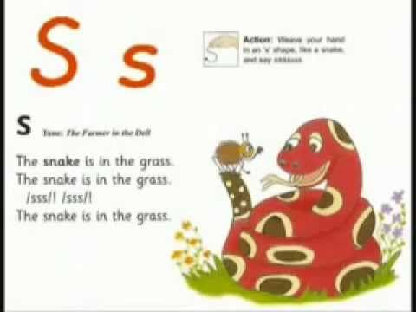  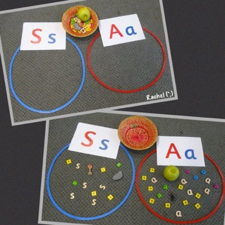  PLAY I SPY  Collect things around the house that start with the sound sssss | Activity 1 - Daily reading  Log on to Active Learn You will have been sent your password via dojo  https://www.activelearnprimary.co.uk/login?c=0  Activity 2 –  Sing https://www.youtube.com/watch?v=0kZQWxNBcL4  Colour in the I spy sheet all the pictures beginning with ssss  Have a go at writing a “s “ in the air , on a piece of paper, with chalk etc  Watch the video to help you form the letter correctly.  https://www.youtube.com/watch?v=Z88An0KpuYo  If your child struggles with this hold their pencil, paintbrush/ hand to help them form the letter correctly. Don’t try to make the letter too small. Start off big and get smaller as your child becomes more confident .  See attached sheet for how we teach the letters. | Activity 1 - Daily reading  Log on to Active Learn You will have been sent your password via dojo  https://www.activelearnprimary.co.uk/login?c=0  Activity 2 –  Our rhyme this week is  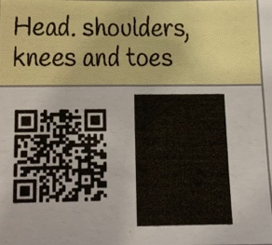  We are looking at parts of the body can you point to each part and name them.  Phonics Today we will introduce the ‘a’  Sound  https://www.youtube.com/watch?v=H6fxDt4nV64  Mr Thorne does phonics ‘a’  PLAY I SPY  Collect things around the house that start with the sound ‘a’  Take a photo of what you have found.  Have a go at writing a “a “ in the air , on a piece of paper, with chalk etc  Watch the video to help you form the letter correctly.  https://www.youtube.com/watch?v=x1nnOO2OFVI | Activity 1 - Daily reading  Log on to Active Learn You will have been sent your password via dojo  https://www.activelearnprimary.co.uk/login?c=0  Draw a picture of your favourite book you have read so far.  Activity 2 –  https://www.teachyourmonstertoread.com/classroom-toolkit/phonics-songs/crazy-stirfry-a-song-hear-it-and-say-it  Learn the Jolly Phonics ‘a’ song  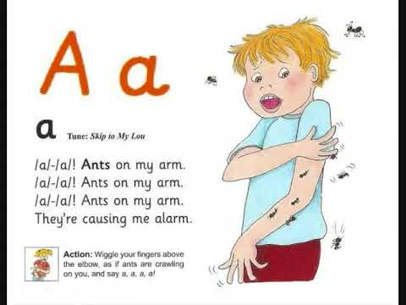  https://www.dailymotion.com/video/x24fi7z  Practise writing ‘s’ and ‘a’.  Keep writing your name  Use a capital at the beginning and the precursive letters for the other letters.
Maths | Count to 10 and back  Watch the below video clip for an explanation of today’s work from a teacher.  https://whiterosemaths.com/homelearning/early-years/week-1/  Watch and complete week 1 session 1  Complete button sheet | Count to 10 and back  Watch the below video clip for an explanation of today’s work from a teacher.  https://whiterosemaths.com/homelearning/early-years/week-1/  Watch and complete week 1 session 2  Play the memory Game | Count to 10 and back  Watch the below video clip for an explanation of today’s work from a teacher.  https://whiterosemaths.com/homelearning/early-years/week-1/  Watch and complete week 1 session 3  Matching the lids | Count to 10 and back  Watch the below video clip for an explanation of today’s work from a teacher.  https://whiterosemaths.com/homelearning/early-years/week-1/  Watch and complete week 1 session 4  Complete Buttons Sheet | Count to 10 and back  .  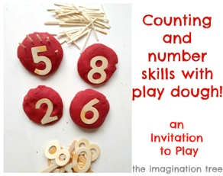  Make some playdough ( Use recipe below)  Write a number 1-5 and get your child to recognise the number count out the match sticks and put the correct amount in  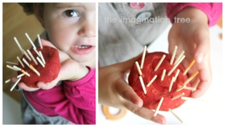  Increase the number as your child becomes more confident with recognition of number snd counting out. | Count to 10 and back  Write down some numbers which numbers do you know ?  Watch  https://www.bbc.co.uk/iplayer/episode/b08bzzns/numberblocks-series-1-one  https://www.bbc.co.uk/iplayer/episode/b08bzgt8/numberblocks-series-1-two  Use the Number blocks 1 and 2 sheet.  You can play snap with the cards or sort them into ones and twos  Practise writing a number 1  And a 2
Topic | Practise using a knife and fork correctly and dressing and undressing your self.  Work on this every day. | Fine Motor  Make some Playdough following the recipe  See attached sheet  Playdough is great for strengthening your child’s fine motor skills which will help their writing.  Have a look at dough disco on You Tube  https://www.youtube.com/watch?v=KSBO8N4ctJg  You can also create whatever you want. Put your pictures on dojo. | Science  Talk to your child about parts of the body using the body mat. Then cut out and label the body part sheet. | Scissor Skills  Practise cutting lots of things out eg pictures from old magazines,  Make sure your child uses the scissors correctly, we don’t want them to get into a bad habit. I have attached a scissor sheet to get you started. Try cutting out something every day. | People and Communities  Talk to your child about their family and who lives in their house .  Complete the In My house sheet | People and Communities  Talk about different types of house eg bungalow, terraced , detached. What number do you live at? What is the street name.  Complete Build a house sheet allowing your child to cut and stick the shapes. They will need help to cut out the smaller parts. Please don’t do it for them encourage them to do it for themselves.

Thursday  24.9.20 | Friday 25.9.20
Activity 1 - Daily reading  Log on to Active Learn You will have been sent your password via dojo  https://www.activelearnprimary.co.uk/login?c=0  Activity 2 –  Our rhyme this week is  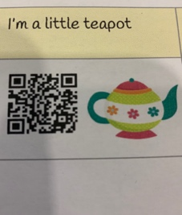  Sing it together. Pick out the rhyming words . Play the rhyme game again  Phonics Today we will introduce the ‘t’  https://www.teachyourmonstertoread.com/classroom-toolkit/phonics-songs/monster-treasure-hunt-t-song-hear-it-and-say-it  PLAY I SPY  Collect things around the house that start with the sound ‘t’  Take a photo of what you have found.  Have a go at writing a “t “ in the air , on a piece of paper, with chalk etc  Watch the video to help you form the letter correctly.  https://www.youtube.com/watch?v=c7iYprpOAxg | Activity 1 - Daily reading  Log on to Active Learn You will have been sent your password via dojo  https://www.activelearnprimary.co.uk/login?c=0  Activity 2 – Sing the song related to t  https://www.dailymotion.com/video/x24fi7z  Practise writing ‘s’ and ‘a’. ‘t’  Keep writing your name  Use a capital at the beginning and the precursive letters for the other letters.  Have a go at some of the activities you have done at home over the last week
Count to 10 and back  .  Look for a circle. Square, triangle and rectangle around your house. Can you make the shapes using pieces of spaghetti or string or lego. Be creative. Show me what you have made. | Count to 10 and back  Watch  https://www.bbc.co.uk/iplayer/episode/b08bzzns/numberblocks-series-1-three  Count out 3 pieces of lego, clap 3 times, count out 3 sweets or biscuits. Can you write a number 3 ? Can you split up number 3 in different ways  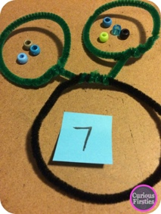
Creative  Create your own collage/ painting/ drawing and put it on Dojo  Or https://www.bbc.co.uk/cbeebies/makes/draw-along-with-evie | PE  Choose a yoga video from here  https://www.youtube.com/user/CosmicKidsYoga

Great Apps to download. https://www.teachyourmonstertoread.com/
https://www.topmarks.co.uk/maths-games/3-5-years
https://www.bbc.co.uk/teach/school-radio/nursery-rhymes-songs-index/zhwdgwx

