Lancashire SEND  Specialist Teacher Resources  Home learning ideas for pupils with Special Educational Needs | The Coronavirus pandemic means that parents and carers of young people with SEND are facing uncertainty. We know schools are on the front line and are playing a hugely important role in keeping communities going in these challenging times. With lots of parents having to teach SEND pupils at home we thought we would send you a weekly themed resources that you can share with your teachers and parents.

Home Learning
In the coming weeks we hope to cover a range of topics that would be suitable for children with a range of learning needs. The topics will vary but will cover broad areas of cognition and learning, communication and interaction, social and emotional wellbeing and sensory and physical needs. We welcome any feedback from parents and carers.
Getting Started  - Have a daily plan – include your child's interests and motivators  - Flexibility – be prepared to change the plan  - Chunk activities with a practical, movement break between. | - Developing life skills is also learning.  - Incorporate a range of tools to engage learning e.g. books, apps, garden, household objects.  - Remember every young child can learn, just not on the same day or in the same way.

Anxiety

Anxiety is part of everyday life, however during the pandemic anxiety may well been increased in children and family members. Including everyday activities which can promote well-being may help families that are struggling to cope during this difficult time. Below is some general advice for parents including activities and links to resources and information. I hope you find it useful.

Advice for Parents/Carers: What to do if my child is worried or anxious about life after lockdown?

Everything has changed very quickly and we had to ask our children to get used to things being different. Lots of children and young people may not understand why we had to make those changes and it might have brought lots of mixed feelings, both good and bad.

Most of us will have changes that we are worried about or make us nervous. These will be different for different people. Some children may worry about some things more than others. Below are some top tips to help you help your children if they are worried or nervous:

Give children space to share their fears. It's natural for children to worry. Let them know they can always come to you for answers or to talk about what scares them. It can help to have ‘worry time’, a set part of the day to get all the worries out. Sometimes children find it helpful to write worries down and throw them away. Remember, no worries are ‘silly’ and try not to use phrases like ‘don’t worry’. Children might be worrying about something which seems small to us as adults but are very real to them!

Know what they’re looking at. Be aware of how your children get news and information, especially older children who go online independently. Point them to age appropriate information so they don't end up finding news that scares them, or gives incorrect information. If you are talking with the other adults around you, or on the phone, just be aware of what kids can hear. They might not always look like they are listening, but it is amazing what they hear! You might want to look at this link which shows how the media shows facts differently to get us to click on their stories. And this BBC Newsround link on how to spot fake Covid-19 news.

Give your child specific things they can do to feel in control and focus on what you are doing to feel safe. Teach children that getting lots of sleep and washing their hands well, eating healthily and exercise can help them stay strong and well. Explain that regular hand washing also helps stop viruses from spreading to others. You can do these things together too.

Talk about all the things that are happening to keep people safe and healthy. Young children might be reassured to know that hospitals and doctors are prepared to treat people who get sick.

Let your children know that it's normal to feel stressed at times. Everyone does. Recognising these feelings and knowing that stressful times pass and life gets back to normal can help children build resilience.

Take small steps. Everyone will have been doing things a bit differently during lockdown. Some children may not have been outside their homes/gardens. Others may have had to go shopping with a parent or been at school and be more used to changes like ‘social distancing’ and seeing people in facemasks. If your child is worried about going out, start small with just a little walk or a drive to see some of the changes. It can help to build up each day (within the guidelines) so that children can do a bit more each day, rather than doing everything all at once.

Resources for younger children talking about anxiety and ways to calm down

Cbeebies ways to help kids keep calm

https://www.bbc.co.uk/cbeebies/joinin/seven-techniques-for-helping-kids-keep-calm

Cosmic Kids YouTube Channel Yoga and Mindfulness for Kids

https://www.youtube.com/user/CosmicKidsYoga/featured

Resources for older children

https://www.youtube.com/watch?v=ME5IZn4-BAk&feature=youtu.be

Video: ways to support young people through anxious times

Headspace is an app and series on Netflix which gives children and adults an introduction to meditation.

Helplines

Childline - Telephone 0800 1111

The Mix - Aimed at people under 25. Telephone 0808 808 4994 from 4pm and 11pm every day of the year. They also run a crisis text service, text THEMIX to 85258.

Crisis Text Line - Text SHOUT to 85258

Activity 1. Worries list

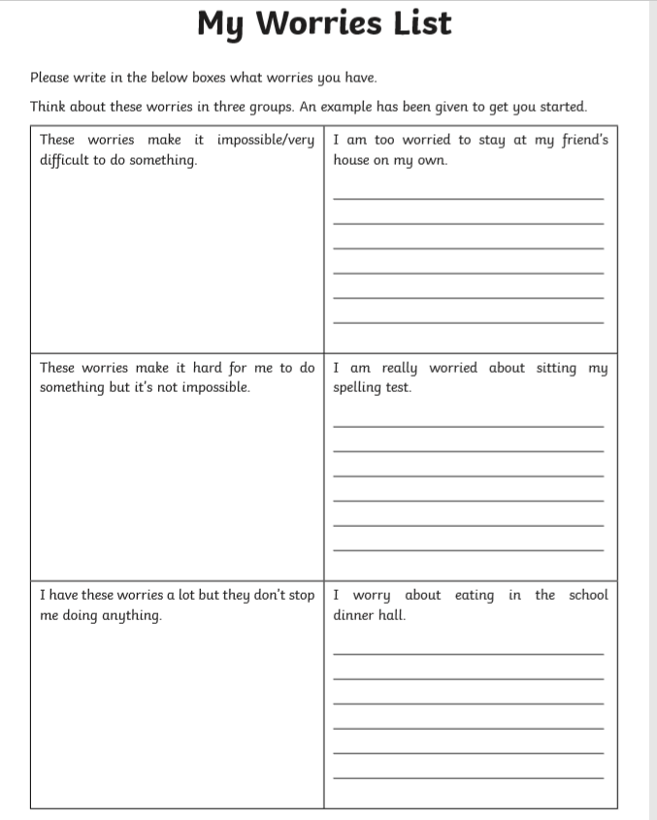

Activity 2.Relaxation Spin Wheel
The relaxation spin wheel is designed to give young people ideas about how to relax. This can be used to calm down after a behaviour incident or when a young person is feeling anxious or stressed. You will need to make the relaxation spin wheel below. Please cut it out and put a split-pin in the middle. You could also paint or draw on a lazy Susan if you want to be more creative. Encourage the young person to spin the wheel and practise doing the relaxation exercise together. Whenever they feel anxious, they can take the relaxation spin wheel out of their pocket or their bag and choose which relaxation strategy to use
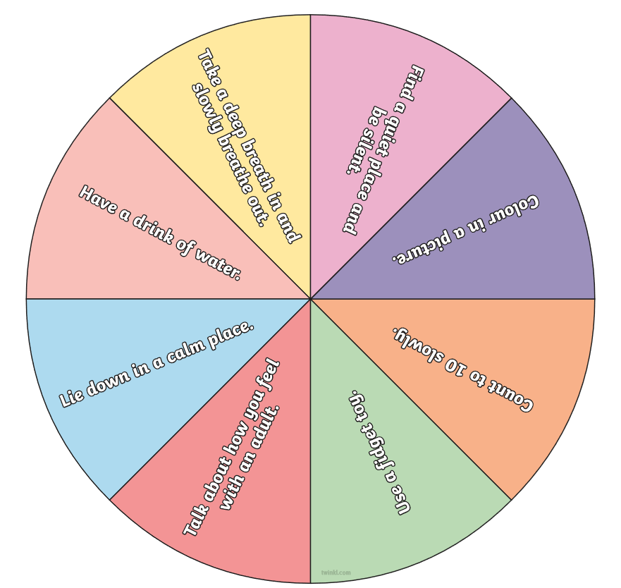

Activity 3. Mindfulness.

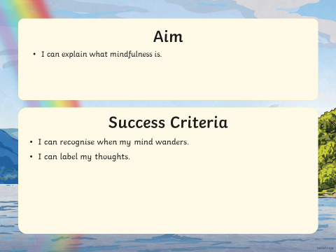

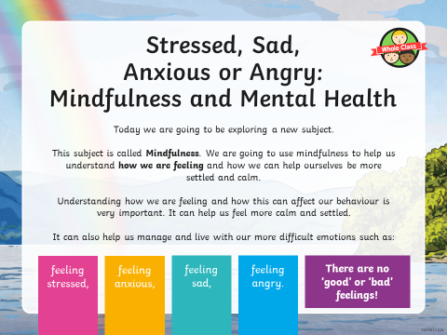
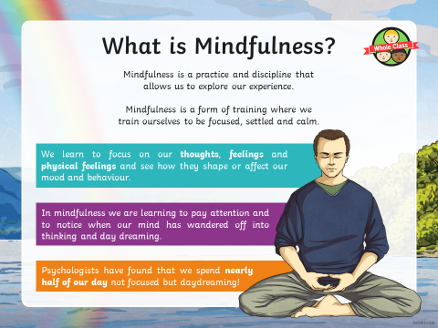

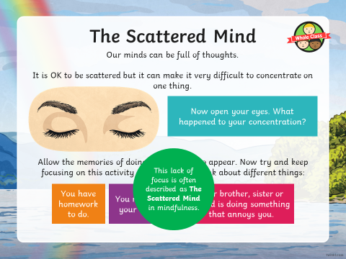
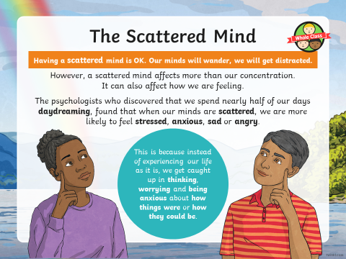

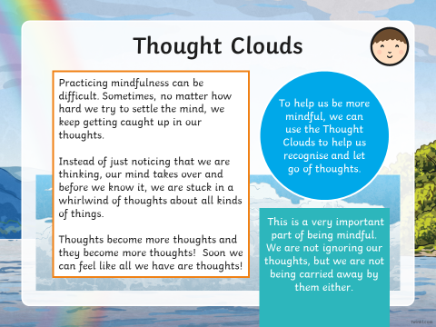

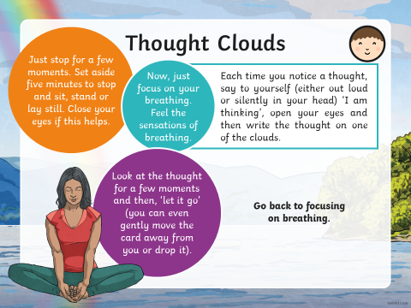

Activity 4. Meditation
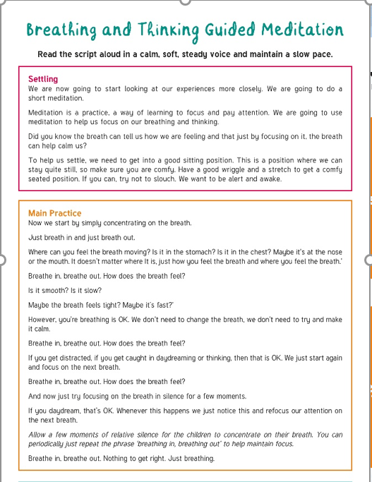

Activity 5. Calm Jar

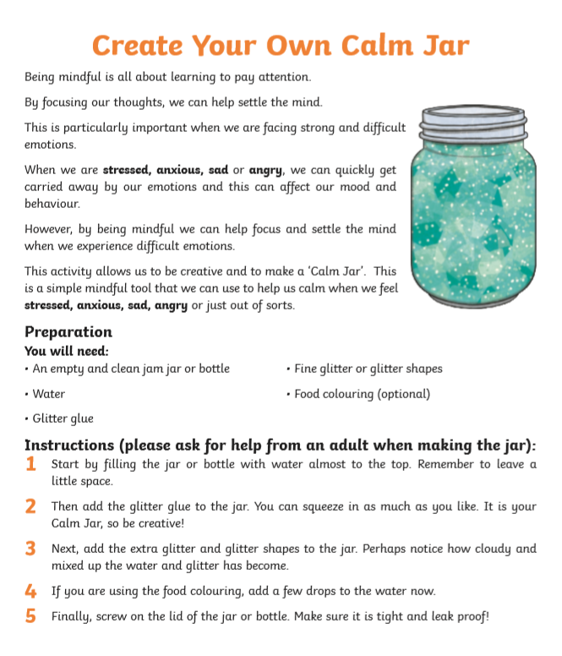

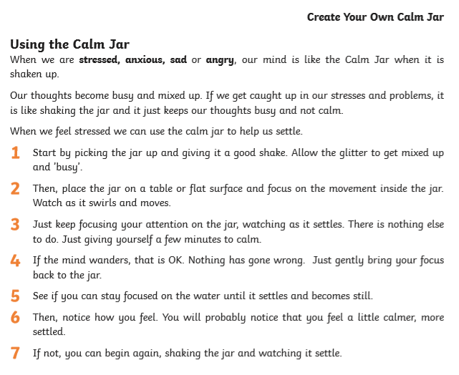

Activities from Twinkle
Twinkle has a range of anxiety activities including flashcards, relaxation techniques, and other helpful suggestions for children can dealing with worries. Please click on the link below:
https://www.twinkl.co.uk/search and search 'anxiety and stress activity pack'

